Computer Systems

2nd Term Assessable Activity

Author:

Roldán Sanchis Martínez

Exercise 1

Section a

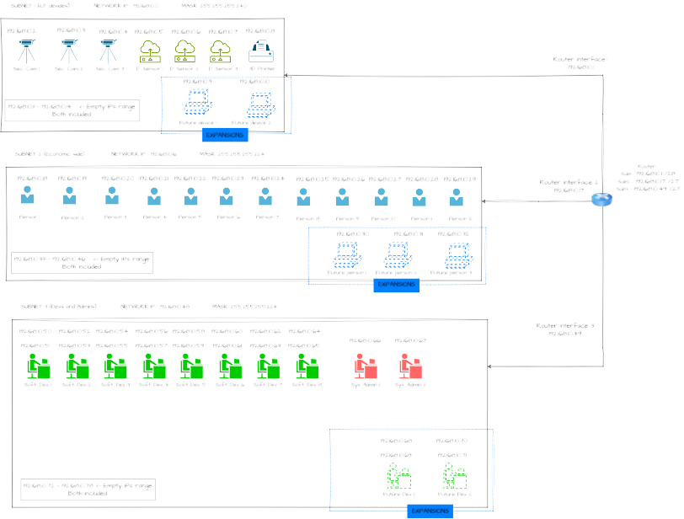

Section b

General info:
Subnet | Network Address | Broadcast Address | Mask | Number of  usable hosts
1 (IoT devices) | 192.168.10.0 | 192.168.10.15 | /28 - 255.255.255.240 | 14
2 (economic side) | 192.168.10.16 | 192.168.10.47 | /27 - 255.255.255.224 | 30
3 (devs and admins) | 192.168.10.48 | 192.168.10.79 | /27 - 255.255.255.224 | 30

Network 1 (IoT devices) :
Device | IP
1- Security camera 1 | 192.168.10.2
2- Security camera 2 | 192.168.10.3
3- Security camera 3 | 192.168.10.4
4- Door sensor 1 | 192.168.10.5
5- Door sensor 2 | 192.168.10.6
6- Door sensor 3 | 192.168.10.7
7- 3D Printer | 192.168.10.8
8- Future IoT device 1 | 192.168.10.9
9- Future IoT device 2 | 192.168.10.10
Router | 192.168.10.1
Empty IPs range | From 192.168.10.11 to 192.168.10.14
Network 2 (Economical Side):
Device | IP
1- Economical person 1 | 192.168.10.18
2- Economical person 2 | 192.168.10.19
3- Economical person 3 | 192.168.10.20
4- Economical person 4 | 192.168.10.21
5- Economical person 5 | 192.168.10.22
6- Economical person 6 | 192.168.10.23
7- Economical person 7 | 192.168.10.24
8- Economical person 8 | 192.168.10.25
9- Economical person 9 | 192.168.10.26
10- Economical person 10 | 192.168.10.27
11- Economical person 11 | 192.168.10.28
12- Economical person 12 | 192.168.10.29
13- Future Ec. person 1 | 192.168.10.30
14- Future Ec. person 2 | 192.168.10.31
15- Future Ec. person 3 | 192.168.10.32
Router | 192.168.10.17
Empty IPs range | From 192.168.10.33 to 192.168.10.46

Network 3 (Devs and Admins):
Device | IP
1- Software dev. 1 | 192.168.10.50
2- Software dev. 1 | 192.168.10.51
3- Software dev. 2 | 192.168.10.52
4- Software dev. 2 | 192.168.10.53
5- Software dev. 3 | 192.168.10.54
6- Software dev. 3 | 192.168.10.55
7- Software dev. 4 | 192.168.10.56
8- Software dev. 4 | 192.168.10.57
9- Software dev. 5 | 192.168.10.58
10- Software dev. 5 | 192.168.10.59
11- Software dev. 6 | 192.168.10.60
12- Software dev. 6 | 192.168.10.61
13- Software dev. 7 | 192.168.10.62
14- Software dev. 7 | 192.168.10.63
15- Software dev. 8 | 192.168.10.64
16- Software dev. 8 | 192.168.10.65
17- Sys. Admin. 1 | 192.168.10.66
18- Sys. Admin. 2 | 192.168.10.67
19- Future soft. dev. 1 | 192.168.10.68
20- Future soft. dev. 1 | 192.168.10.69
21- Future soft. dev. 2 | 192.168.10.70
22- Future soft. dev. 2 | 192.168.10.71
Router | 192.168.10.49
Empty IPs range | From 192.168.10.72 to 192.168.10.48
Exercise 2

Section d

1) docker run -d --name redis-server -p 8001:8001 --rm redis/redis-stack:latest

With -d we run the container in detached mode,
with -p 8001:8001 we map the container port 8001 to the machine port 8001.
with --name we stablish a name for the container,
and with --rm remove the container when stopped.

2) We can do it locally or using the nano command like this:
nano Dockerfile
And then modifing the content.

3) docker build -t flask-server /home/rolsanma/CS

//CS is the base directory where Dockerfile is
With -t we set a tag for the image.

4) cd app
to change to the app directory from /home/rolsanma/CS
After that, using
docker run -d -v $(pwd):/python/app -p 5000:5000 flask-server
With -d we run in detach mode,
with -v we mount the volume that binds /app in the container with /app on the machine,
with -p we map the ports.

Final content of Dockerfile:

FROM python:3.8-slim

COPY requirements.txt /requirements.txt
RUN pip install --no-cache-dir -r /requirements.txt
ENV FLASK_APP=/python/app/app.py
ENV FLASK_RUN_HOST=0.0.0.0
ENV FLASK_ENV=development
ENV REDIS_SERVER=redis-server
CMD [“flask”,”run”,”--debug”]

